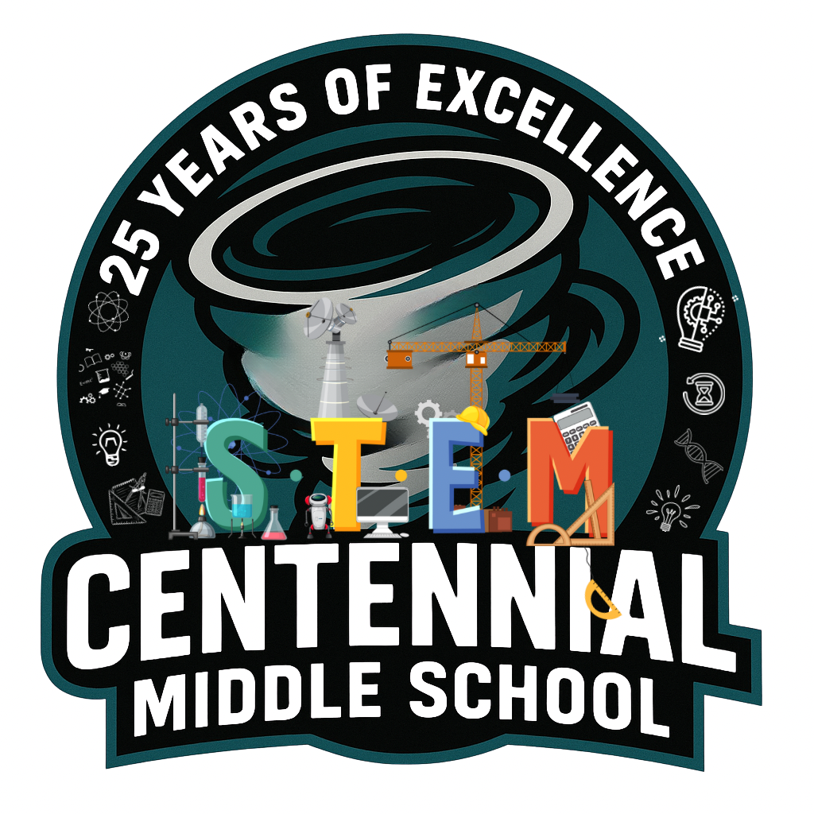

**Centennial Middle STEM Magnet School**

**Title 1 Parent and Family Engagement Plan**

**2025-2026**

**Mission Statement**

At Centennial Middle STEM Magnet School our staff, parents and community are committed to providing a quality STEM education for ALL students to become lifelong-innovative learners and responsible community stake-holders.

**Title 1 Families/Parents/Caregivers**

Centennial Middle School will involve parents in the development of the Title 1 plan and the school improvement process.

• An annual meeting will be held to which all CENMS families are invited and encouraged to attend. The purpose of the meeting is to inform parents of the school’s participation in the Title I program and of the parent’s right to be involved.

• Parents will be provided access to information on school performance data and assistance interpreting their child’s individual assessment results.

• Parents will be provided a description and explanation of the curriculum and standards used at the school, the forms of assessment used to measure student progress, and the proficient levels students are expected to meet.

• Parents will be invited and encouraged to attend monthly SAC (School Advisory Council) meetings to offer suggestions, share experiences and to participate in decisions related to the education of their children.

• Parents will be invited and encouraged to attend parent informational meetings at the school and virtually through zoom meetings.

**Parent Involvement Opportunities**

Centennial Middle School will support and encourage active parent involvement in the home and at school in many ways. In order to meet the needs of our families Centennial Middle School will provide the following:

• Parent workshops will be offered at convenient times to assist parents with providing a supportive home environment.

• Opportunities for volunteering.

• A variety of school events that families are invited to and encouraged to attend.

• Opportunities for families to share their feedback about school events.

• Parent / teacher conferences.

• An annual survey for parents to complete to help the school meet the needs of Centennial Middle families.

**Communication**

Centennial Middle School provides their families with ongoing and timely communication. Some of the ways that Centennial Middle School communicates information to families include:

• Emails

• Ongoing Parent/Teacher/Student Conferences

• Individual and automated phone calls (School Messenger)

• myStudent (electronic grade book and attendance)

• Social Media: Twitter and Facebook

• CENMS Website

• CENMS Marquee (school sign)

• CENMS Cyclone Storm Watch Parent Newsletter

The Centennial Middle School web site will be updated and easy to use. It will provide the following information:

• Teacher and Staff Contact Information including email

• District School calendar

• Parent and Student Resources

• School lunch menu

• Current school events calendar

• Athletic Information

• Social media

• Title I information

Centennial Middle School will partner with our families using a School/Home Compact. The compact will state the expectations and goals for the student, parents and school. Parents, students, and the entire staff will share the responsibility for improving academic achievement and social well-being. This shared partnership will provide all students with opportunities to be college, career and life ready.

Annually, the SAC will review and make recommendations for the Parent Involvement Plan and the School/Home Compact. Families are encouraged to submit their feedback regarding school events and the Parent Involvement Plan.

For more parent resources, parents may view the website www.floridapartnership.usf.edu for more information. This document will be made available to all parents annually. Centennial Middle School shall ensure opportunities and information are accessible to all families. Please contact the school if you require additional assistance