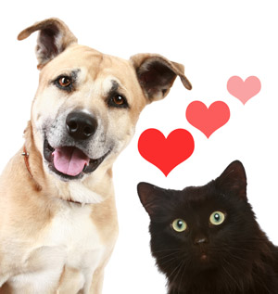

Centennial Middle School’s FFA is hosting a Valentine’s Day Pet Food Drive.

We will be collecting these items from January 14 thru February 12, 2016

Items needed:
Dry dog and cat food
Canned dog and cat food
Dog and cat treats
Dog and cat toys
Dog and cat blankets

****All items must be new and unused*****

FFA members will be picking these items up during 1st period and students who donate will receive a thank you goody bag.

If you have any questions, please contact Sally Campbell (FFA President) or Kelly Bonin (FFA Advisor)

